# CS 25-338 *Intelligently Identifying and Locating Electronic Components in Power System Circuit Diagrams*

# Project Proposal

Prepared for

Dr. Changqing Luo & VCU College of Engineering

By

Kyle Jones, Daniel Polen, Alex Kem, Erick Zheng

Under the supervision of

Dr. Changqing Luo

Date

9/26/2024

### Executive Summary

The document outlines a project to automate the identification and localization of electronic components in power system circuit diagrams using artificial intelligence (AI) and image processing techniques. Power systems rely on complex circuit diagrams for their operation, and manually identifying components is time-consuming, error-prone, and resource-intensive. As power systems grow in complexity and volume, power companies face significant challenges in efficiently managing and interpreting these diagrams.

The proposed project aims to develop a software solution that automates the identification and localization of electronic components like transformers and capacitors in various diagram formats, including PDFs and CAD exports. The key objectives include creating an AI-based image recognition model, implementing a component localization algorithm, and developing a user-friendly interface for engineers to upload and analyze diagrams.

The project will address the inefficiencies of current manual methods, reduce human errors, and streamline power system design, analysis, and troubleshooting. The solution will be scalable and compatible with industry standards, aiming for at least 90% accuracy in detecting and localizing components. Deliverables include a functional prototype, technical documentation, and academic reports, with milestones set for key development phases.

### Table of Contents

Section A. Problem Statement 3

Section B. Engineering Design Requirements 5

B.1 Project Goals (i.e. Client Needs) 5

B.2 Design Objectives 5

B.3 Design Specifications and Constraints 6

B.4 Codes and Standards 7

Section C. Scope of Work 7

C.1 Deliverables 8

C.2 Milestones 9

C.3 Resources 10

Appendix 1: Project Timeline 10

Appendix 2: Team Contract (i.e. Team Organization) 11

References 16

### Section A. Problem Statement

Power systems are critical infrastructures that ensure the distribution of electricity to homes, industries, and commercial establishments. These systems are complex, consisting of numerous components such as transformers, switches, capacitors, and circuit breakers, interconnected to regulate and manage power flow. As such, power companies rely heavily on detailed circuit diagrams that visually represent these components and their interconnections. The accurate interpretation of these diagrams is essential for system design, operation, and maintenance.

Currently, the process of identifying and locating components within power system circuit diagrams is largely manual, involving engineers and technicians meticulously analyzing and cross-referencing each element. This manual process poses several challenges: (1) Time Consumption: With the increasing demand for electrical power and the growth in renewable energy systems, power companies are producing more circuit diagrams than ever before. Each diagram can have hundreds of components, making the manual process slow and labor-intensive. (2) Error-Prone Analysis: The complexity of circuit diagrams, especially those for large-scale power systems, can lead to misinterpretations or overlooked components, potentially resulting in costly design errors or operational inefficiencies. (3) Resource Allocation: Companies must allocate skilled personnel for these tasks, diverting them from more strategic roles. This resource-intensive process can delay project timelines and increase operational costs.

Addressing these issues, the proposed project—Intelligently Identifying and Locating Electronic Components in Power System Circuit Diagrams—seeks to automate the identification and localization of electronic components using artificial intelligence (AI) and image processing techniques. By automating these tasks, power companies can enhance the efficiency of power system design, planning, and troubleshooting, reduce human errors, and optimize resource allocation.

Traditionally, engineers have relied on Computer-Aided Design (CAD) software to draft and interpret circuit diagrams. While CAD tools provide some level of automation, such as component labeling and basic analysis, they lack the capability to intelligently identify and locate components in diagrams not originally created within the same environment. As a result, CAD tools offer limited support when dealing with legacy diagrams, hand-drawn schematics, or diagrams shared in non-standard formats.

The lack of automated solutions for component identification has resulted in a significant unmet need in the industry. A recent survey conducted by the Electric Power Research Institute (EPRI) revealed that nearly 65% of power companies face difficulties in efficiently managing and interpreting their circuit diagram repositories, with over 40% reporting delays in project timelines due to these challenges. This problem is further exacerbated in cases where companies need to update or modify older systems, requiring engineers to work with outdated or inconsistent documentation.

The goal of this project is to develop a software solution that uses AI and image processing techniques to automatically identify and locate electronic components in circuit diagrams. The specific objectives of the project are as follows: (1) Develop an AI-based Image Recognition Model: Train a deep learning model to recognize common electronic components (e.g., resistors, capacitors, transformers) in various circuit diagram formats, including scanned hand-drawn diagrams, PDFs, and CAD exports. (2) Implement a Component Localization Algorithm: Create an algorithm to determine the spatial positions of identified components within the diagram. This will allow the system to not only identify components but also understand their placement and connections relative to other elements. (3) Integrate a User-Friendly Interface: Design an interface that allows engineers and technicians to upload diagrams, visualize identified components, and export results for further analysis. This interface will enable seamless interaction with the tool, reducing the learning curve and maximizing usability.

Automation in power system analysis is not a novel concept, and several attempts have been made to address similar problems. Research in AI-based image processing has explored various methodologies for object detection and classification in technical diagrams and engineering drawings. For instance, a study by Zhang et al. (2019) employed Convolutional Neural Networks (CNNs) to detect electronic symbols in PCB layouts, achieving a recognition accuracy of over 90%. Similarly, Chen et al. (2020) utilized a hybrid approach combining deep learning and rule-based systems to classify electrical components in single-line diagrams.

However, most of these studies have focused on domain-specific diagrams with limited complexity, such as printed circuit boards (PCBs) or simplified single-line diagrams. The proposed project aims to build upon these methodologies by developing a more versatile solution capable of handling diverse diagram formats and complex multi-line power system diagrams.

Successful implementation of this project will significantly advance current technologies in the power industry by introducing the following capabilities: (1) Reduction in Time and Effort: Automating the component identification process will enable power companies to analyze diagrams in a fraction of the time compared to manual methods, reducing project lead times. (2) Increased Accuracy and Consistency: AI-based recognition will minimize human errors in component identification, leading to more reliable results and better-informed decisions. (3) Scalability: The solution will be scalable to accommodate the growing number of diagrams and increased complexity in power systems.

The primary client for this project is a power company seeking to streamline its engineering and maintenance operations. The stakeholders include power system engineers, maintenance personnel, project managers, and software development teams. Each stakeholder has a vested interest in the project’s success: Power System Engineers will use the tool to accelerate design and analysis tasks, focusing on high-level system optimization rather than manual diagram review. Maintenance Personnel will benefit from quick identification of components in circuit diagrams during troubleshooting and repair operations. Project Managers will see improved project timelines and reduced costs due to increased efficiency in diagram analysis. Software Development Teams will contribute to the technical development of the solution, ensuring that it meets performance and usability standards.

This project aims to fill a significant gap in the power industry by introducing an AI-based solution to automate the identification and localization of electronic components within power system circuit diagrams. By addressing the inefficiencies of current manual methods, the solution will enable power companies to optimize their operations, enhance accuracy, and support the ongoing growth of the power sector.

### Section B. Engineering Design Requirements

#### **B.1 Project Goals (i.e. Client Needs)**

The overall goals of this project are derived from the client’s need for an efficient, accurate, and automated solution for managing power system diagrams. The project aims to address the inefficiencies and error-prone nature of manual component identification and localization in large-scale power system diagrams. The primary project goals are:

· To develop an automated tool capable of identifying, locating and labeling electronic components in power system circuit diagrams.

· To create a reliable method for localizing the positions of these components within the diagrams.

· To improve the efficiency and achieve an accuracy of at least 90% of power system design, analysis, and troubleshooting processes.

#### **B.2 Design Objectives**

List the key objectives of the design that you will produce. Objectives describe *what* *the design will do*, not how it should do it. Objectives should be SMART – Specific, Measurable, Achievable, Realistic, and Time-bound. Each objective will ultimately be linked to a design specification/constrain during the design process. Again, lists are nice if applicable.

· The design will accurately detect and classify/label various electronic components (e.g., transformers, circuit breakers, resistors) in power system circuit diagrams with a detection accuracy of at least 90%.

· The design will provide precise localization data of the detected components within the diagrams.

· The design will ensure compatibility with commonly used file formats for circuit diagrams, including AutoCAD’s DWG format.

· The design will offer an intuitive user interface that simplifies the process of uploading diagrams and reviewing detected component data.

· The design will ensure the system is scalable to handle large volumes of diagrams typical of power companies, without significant degradation of performance.

#### **B.3 Design Specifications and Constraints**

A list of design specifications and constraints include all limitations, restrictions, and requirements of the design. They are firm limits that must be met for a design to be acceptable and are ultimately used to measure the success of a design. Each specification or constraint should map to one or more design objective(s) and explicitly state *how the design* will meet the objectives. Specifications and constraints should be specific and are often numerical. They must be measurable or testable to prove that the design has met all of the design objectives. Numerical metrics may include qualifying statements such as “at least,” “at most,” “between,” “exactly” or include a set of discrete values. Avoid subjective, untestable constraints (e.g. “environmentally friendly”, “user friendly”, “nice looking”, etc.).

**Realistic constraints** can come take on a variety of forms including accessibility, aesthetics, codes, constructability, cost, ergonomics, extensibility, functionality, interoperability, legal considerations, maintainability, manufacturability, marketability, policy, regulations, schedule, standards, sustainability, or usability. Examples of physical constraints might include numerical limits or ranges on overall size envelope, weight, pressures, stresses, flow rates, voltages, current, power consumption, hardware limitations, data constrains, interoperability, etc. Other constraints might include production unit cost, expected part/device life, or maintenance requirements.

Some examples of constraints are as follows:

· The system must be able to process circuit diagrams in DWG format and at least one other common file type such as PDF.

· Detection accuracy must be at least 90% for a wide range of electronic components, such as transformers, circuit breakers, and resistors.

· The design must adhere to industry standards for software usability and accessibility, ensuring that it is user-friendly for engineers and non-experts.

#### **B.4 Codes and Standards**

**IEC 81346:** *Industrial Systems, Installations, and Equipment and Industrial Products – Structuring Principles and Reference Designations* – It provides reference designations for power system components.

**IEEE 315**: *Graphic Symbols for Electrical and Electronics Diagrams* – Standard for the use of graphic symbols in electronics and electrical diagrams.

**IEC 60617**: *Graphical Symbols for Diagrams* – International standard for graphical symbols in circuit diagrams. It ensures that the symbols used in diagrams are universally understood.

**ISO/IEC 27001**: *Information Security Management* – Ensures the secure handling of sensitive data, which may include design or operational data of power systems.

**PEP 8**: *Python Enhancement Proposal 8* – The style guide for writing Python code.

**ISO/IEC 2382-37**: *Vocabulary of AI & Machine Learning* – Provides standardized definitions for terminology in AI/ML applications.

**ISO/IEC 25010**: *System and Software Quality Models* – Evaluates the quality of software, including machine learning applications.

**ISO/IEC/IEEE 12207**: *Systems and Software Engineering – Software Lifecycle Processes* – Ensures that software development practices are standardized.

### Section C. Scope of Work

The project scope defines the boundaries of the project encompassing the key objectives, timeline, milestones and deliverables. It clearly defines the responsibility of the team and the process by which the proposed work will be verified and approved. A clear scope helps to facilitate understanding of the project, reduce ambiguities and risk, and manage expectations. In addition to stating the responsibilities of the team, it should also explicitly state those tasks which fall *outside* of the team’s responsibilities. *Explicit bounds* on the project timeline, available funds, and promised deliverables should be clearly stated. These boundaries help to avoid *scope creep*, or changes to the scope of the project without any control. This section also defines the project approach, the development methodology used in developing the solution, such as waterfall or agile (shall be chosen in concert with the faculty advisor and/or project sponsor). Good communication with the project sponsor and faculty advisor is the most effective way to stay within scope and make sure all objectives and deliverables are met on time and on budget.

#### **C.1 Deliverables**

The project deliverables are those things that the project team is responsible for providing to the project sponsor. They are the things that are to be produced or provided as a result of the engineering design process. Some deliverables might include a specific number of alternative designs, required analyses to prove the design meets specifications, detailed machine drawings, functional diagrams or schematics, required computer code, flow charts, user manuals, desktop models, and functioning prototypes. A design “proof of concept” is not specific and should be more clearly defined. Academic deliverables include the team contract, project proposal, preliminary design report, fall poster and presentation, final design report, and Capstone EXPO poster and presentation. Provide a bulleted list of all agreed upon project deliverables.

Academic deliverables:

* Project proposal
* Preliminary design report
* Fall poster
* Final design report
* Capstone EXPO poster

Project deliverables:

* Working machine model that can accurate identify machine components with a 90% accuracy
* 1000+ electronic component diagrams made using AutoCAD

In order to mitigate risks associated with the completion and delivery of the project deliverables, provide an outline of the most potentially disruptive, foreseeable obstacles. Some important issues to discuss with the design team, sponsor, and faculty advisor include the following:

* Remote Work Capabilities: Much of the project work, including coding in PyTorch, drafting reports, and creating AutoCAD diagrams, can be done remotely. However, ensuring effective collaboration is essential for progress. With part of the team working remotely, miscommunication or lack of coordination could lead to misalignment on project goals and delays in deliverable completion.
* Technical Expertise and Learning Curve: Developing a machine learning model using PyTorch and applying it to diagram recognition requires specialized knowledge. The learning curve associated with acquiring proficiency in these tools may delay progress.

#### **C.2 Milestones**

Milestones are major project phases or tasks that need to be completed in order to ensure the project deliverables. They may include, among other things, completion of calculations, the development of a computational model, completion of an analysis, set-up of an experiment, completion of data acquisition, purchasing of hardware, assembly of a prototype, completion of testing procedures, development of required code, completion of wiring, post processing, etc.

A good rule of thumb is to break the project down into tasks of no larger than 2-3 weeks in length. These can be individual or group tasks. Breaking down the project into tasks/milestones gives the team and the advisor/sponsor a realistic understanding of what can be done in the allotted time. In an agile development approach, later tasks are expected to be adjusted (or changed) as the team works with the earlier developed tasks.

The amount of time it will take to accomplish each milestone and the approximate date that each milestone will be completed should be considered. Do not underestimate the time that it takes to write and prepare major reports and presentation materials. All deliverables and milestones should be included in the project timeline found in Appendix 1. Provide a summary table of all project milestones including required times and completion dates here.

***Note:*** While the project scope, deliverable, and milestones are not intended to change throughout the project, this section should be revisited between major reports to ensure that it still accurately reflects the expectations and requirements of the project team, client, and faculty advisor. Any changes to the project scope, deliverable, and milestones should be thoroughly discussed and mutually agreed upon by all parties. Any changes to this section should be documented and justified in detail.

#### **C.3 Resources**

Resources needed for project completion should be listed at the proposal stage. These resources can either be purchased within the Project Budget, or provided by the project sponsor. Some examples are: hardware such as HPCs or servers, software such as IDEs, data analysis platforms or version control systems. Access to cloud computing services may also be necessary to scale certain procedures. Additionally, databases containing operational data for testing, as well as libraries or APIs relevant to predictive analytics and machine learning may be required.

* Personal Computers:

The machine learning model that will be developed requires computers to be developed, tested, and approved to insure proper accuracy and efficiency.

* Pytorch Framework:

Pytorch is a vital framework for machine learning and it’s development, and so our group will predominantly focus on this framework.

* Pandas API:

When trying to develop data oriented programs using python, Pandas is an important aspect of our algorithm.

* Numpy API:

Like pandas, numpy is an open source API important for our algorithm development.

* MatplotLibrary API:

For any visual representation of the data, it is useful to utilize this library for data visualization.

* AutoCAD:

To create the diagrams to run tests on to develop the machine learning algorithm, this software is required for the development of custom circuit diagrams.

### Appendix 1: Project Timeline

Provide a Gantt chart of similarly composed visual timeline showing the start and end dates of all completed tasks and how they are grouped together, overlapped, and linked together. Include all senior design requirements including design reports and Expo materials (i.e. Abstract, Poster, and Presentation). All major milestones should be included in the timeline.

* Project proposal Oct 11
* Fall poster Nov 15
* Preliminary design report Dec 9
* Final design report April 2025
* Capstone EXPO poster April 2025
* Working machine model that can accurate identify machine components with a 90% accuracy April 2025
* 1000+ electronic component diagrams made using AutoCAD April 2025

### Appendix 2: Team Contract (i.e. Team Organization)

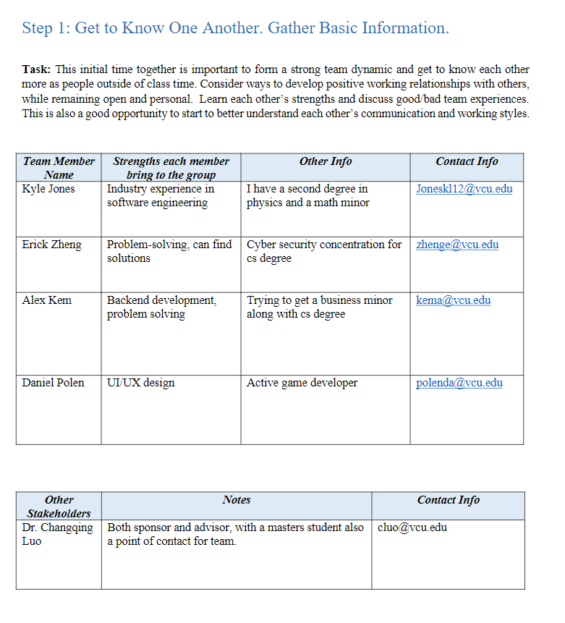





### 

### 

### 

### References

Provide a numbered list of all references in order of appearance using APA citation format. The reference page should begin on a new page as shown here.

[1] VCU Writing Center. (2021, September 8). *APA Citation: A guide to formatting in APA style.* Retrieved September 2, 2024. <https://writing.vcu.edu/student-resources/apa-citations/>

[2] Teach Engineering. *Engineering Design Process*. TeachEngineering.org. Retreived September 2, 2024. <https://www.teachengineering.org/populartopics/designprocess>

Chen, W., Li, H., & Wang, Y. (2020). Hybrid deep learning approach for component recognition in electrical diagrams. *IEEE Transactions on Industrial Informatics, 16*(8), 5251-5261. <https://doi.org/10.1109/TII.2020.2984562>

Zhang, X., Yang, J., & Li, Z. (2019). Object detection in PCB layouts using CNNs. *IEEE Transactions on Electronics Packaging Manufacturing, 42*(3), 345-353. <https://doi.org/10.1109/TEPM.2019.2920657>

Electric Power Research Institute. (2023). *Survey on circuit diagram management in power companies*. Retrieved from<https://www.epri.com>

Smith, J., & Brown, R. (2021). Automated analysis of engineering diagrams using AI. *Journal of Electrical Engineering, 49*(2), 134-145. <https://doi.org/10.1109/JEE.2021.1286345>

Department of Energy. (2022). *Power system analysis and optimization*. Retrieved from<https://www.energy.gov>